SDLC (Software Development Life Cycle)
The Software Development Life Cycle (SDLC) is a systematic process used to design, develop, test, and deploy high-quality software. It ensures the project meets customer requirements while maintaining efficiency and reducing risks.
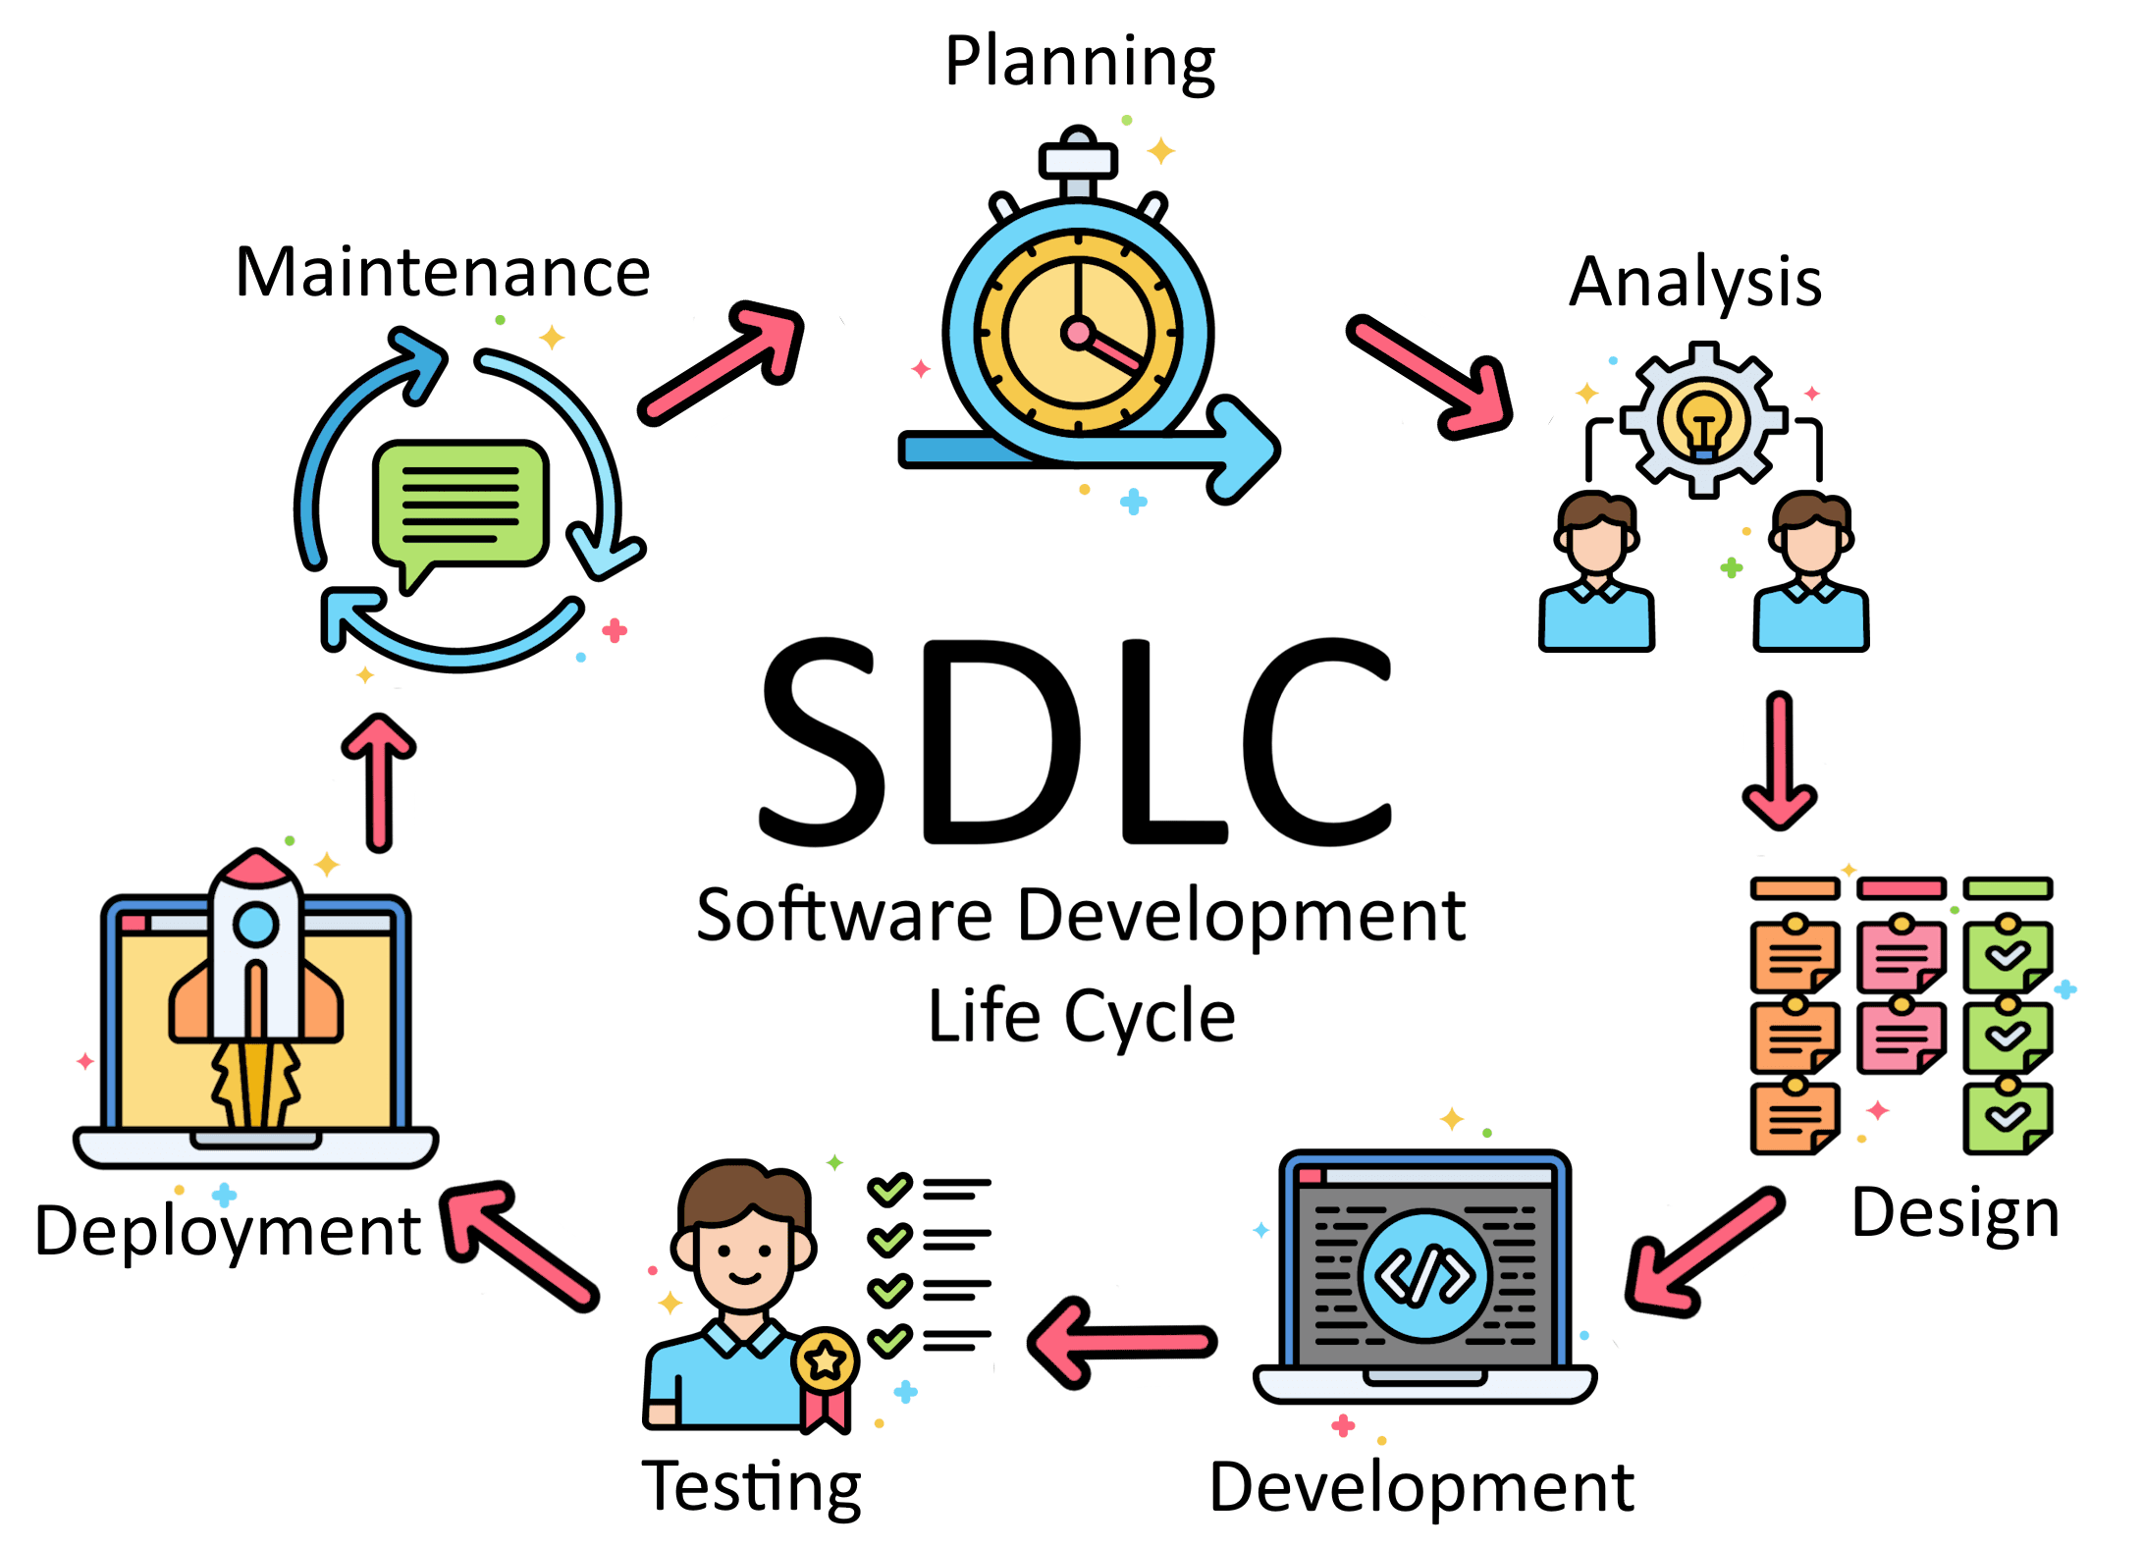
Why SDLC is called a Cycle
It is called a cycle because the process repeats after deployment. Software requires:
- Continuous improvements
- Bug fixes
- New feature additions
Each update again follows: Requirement → Design → Development → Testing → Deployment. Thus, SDLC forms a continuous loop.

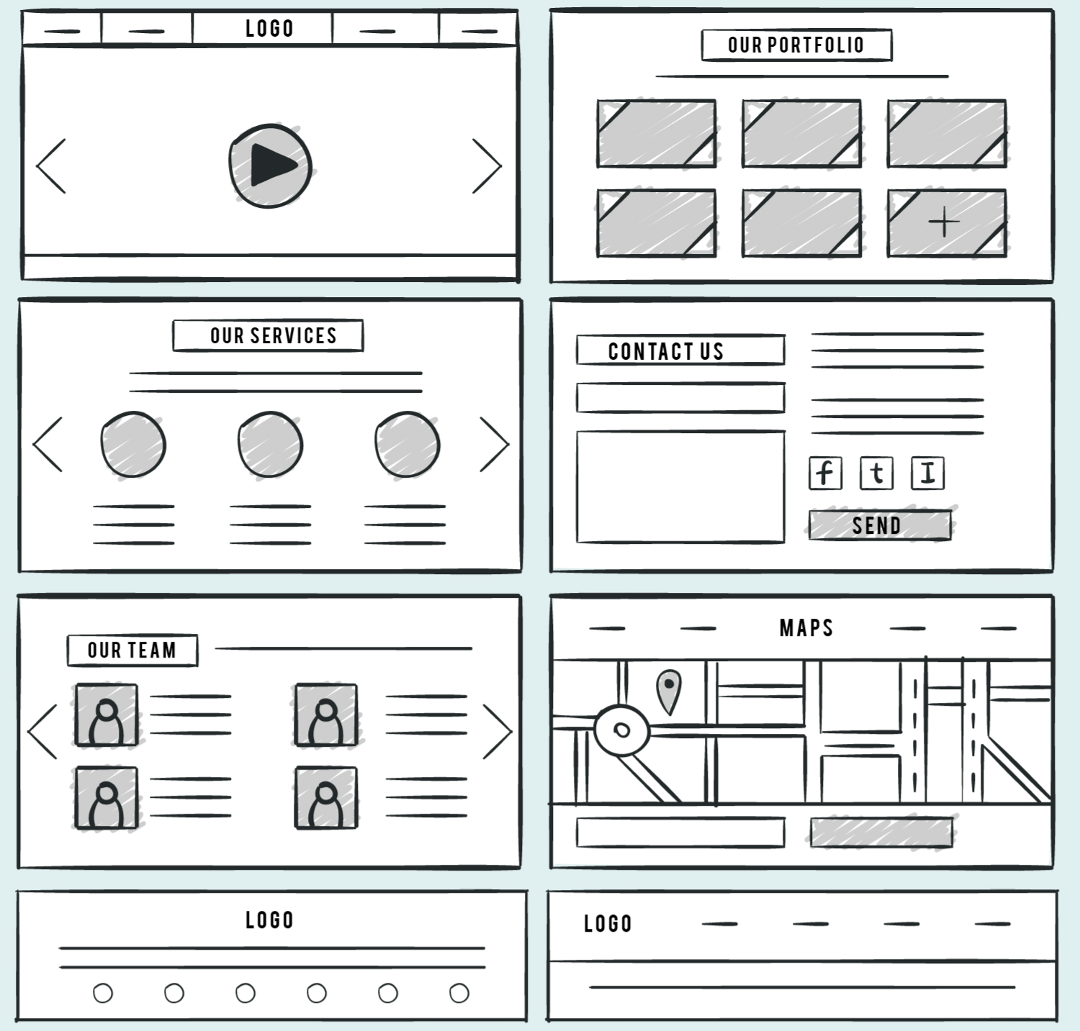
1. Requirement Document
The requirement phase involves gathering complete information about what the client or product owner expects from the system.
Includes:
- Textual descriptions of features
- Wireframes and UI sketches
- Abstracts and requirement summaries
- Functional & non-functional requirements
Prepared by: Product Owner (PO) / Client

2. Technical Document
Prepared by the Tech Lead (TL) or Architect after understanding the requirements. It undergoes multiple reviews to ensure technical feasibility.
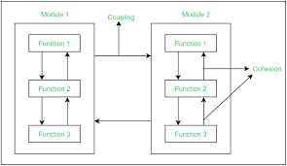
Contains:
- System architecture
- Number of classes
- Interfaces to be used
- Inheritance structure
- Components and modules breakdown
- Technology stack and design patterns

3. Coding Phase
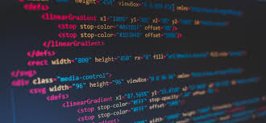
Development officially begins in this stage.
Roles involved: SSE (Senior Software Engineer), SE (Software Engineer)
Activities:
- Writing clean and modular code
- Integrating components
- Implementing functionalities
- Unit testing
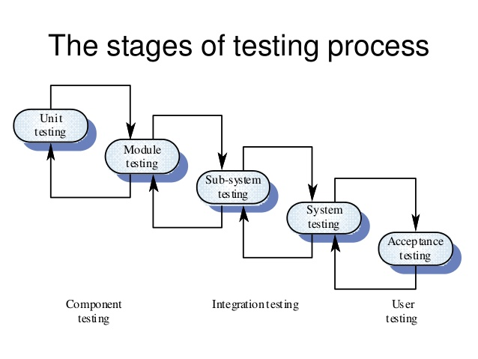
4. Testing (QA Phase)
Build is deployed on the QA Server.
QA Team responsibilities:
- Execute test cases
- Identify defects
- Log bugs
- Validate fixes

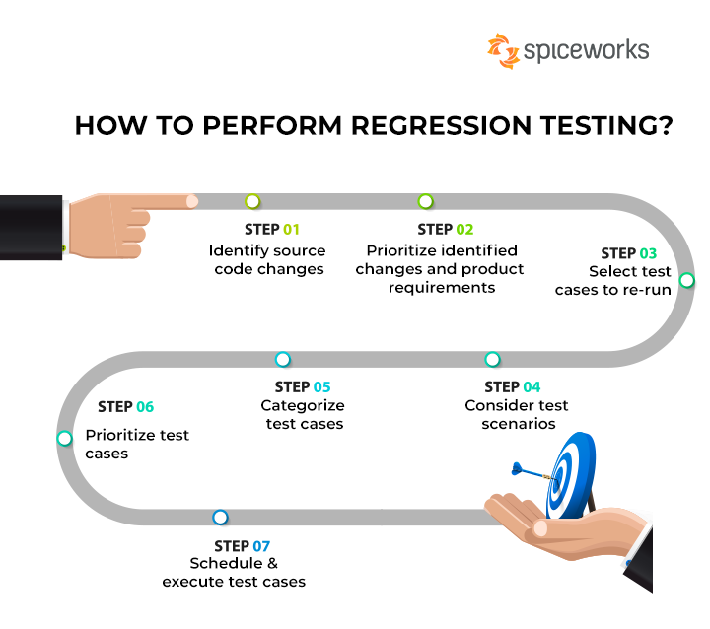

5. Staging Environment
Used for advanced and near-production testing.
Includes:
- Regression Testing
- Load & Performance Testing
- Automation Test Cases


6. UAT Environment (User Acceptance Testing)
Client tests the application for:
- Functionality
- Usability
- Business flow

7. PPE (Pre-Production Environment)
Final testing stage before production.
Used for:
- Final validations
- Dry run deployment
- Configuration checks


8. PE – Production Environment (GO LIVE)
Application is deployed for real users.
Activities:
- Actual deployment
- Monitoring performance
- Ensuring stability

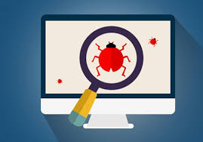
9. Bugs – Maintain
Post-production maintenance involves:
- Fixing user-reported bugs
- Delivering patches
- Enhancements

